# TECHNICAL OVERVIEW

Major Systems:

* Core (core.cpp)
* Factory (factory.cpp)
* Physics (physics.cpp)
* Graphics (graphics.cpp)
* Audio (audio.cpp)
* Game Logic (logic.cpp)

Components

* Transform
* RigidBody
* Sprite
* Logic
* Etc.

What major technologies are you using?

* DirectX 9.1
* FMOD Designer
* Custom 2D Physics
* Etc.

Describe/show the overall architecture of the project.

# CODING METHODS

In order to comply with Visual Studio conventions and maintain a somewhat self-documenting structure, it is expected that every C++ class or object belongs to a group of similar objects. Each group is given its own folder, and each folder is given its own Visual Studio filter. For instance, the camera, sprites, and textures are all handled by some portion of the engine’s graphics. All of these files then are put into an “engineGraphics” folder, and all contents of this folder are put into an “engineGraphics” filter.

The only real file naming convention can be described as “some sort of camel case”. That is, either “camelCase.cpp” or “CamelCase.cpp” would be acceptable, and each file name should indicate one of the following

* The file’s primary purpose
* The primary C++ class found in the file

Nearly every .h (C/C++ header) file is given a macro-defined “code guard”:

|  |
| --- |
| #ifndef DEMO_H  #define DEMO_H  void demoFunction();  #endif |

All C/C++ files are expected to be in the folder that the Visual Studio project reads from (“GAM200_PROJECT”). Other files and sub-projects are to be put into the same directory that this folder is in.

|  |
| --- |
|  |

A DigiPen git repository is used; all team members have been trained in using SourceTree in order make changes available to the rest of the team, and ensure that changes other team members have made are intact. When a merge fails, procedure depends on which file the merge failed for, and how simple the merge looks. (“Mine” refers to the working index/files of the merger, “they” refers to the last-known person to modify the files for which the conflict is failing).

* GAM200_Project.vcxproj.filters
  + Resolve using “mine”, but add the files “they” added.
* _EntryPoint.h
  + This file is very easy to modify, so resolution can be ignored.
* Simple C++ Implementation
  + Stage lines, but test compilation before pushing the merge.
* Highly complex (or non-documented) C++ Implementation
  + Contact whoever “they” happen to be
  + Failing that, or in cases where the merge causes the project “break” in a non-trivial manner, get Nolan.

# DEBUGGING TOOLS

Our team-built debugging tools mainly consist of:

* The standard command line window attached to a standard C++ project
* A system that allows us to create additional command line windows.
* A debug drawing system that is able to draw lines, circles, and rectangles.
  + In most cases, the function parameters are self documenting, with the exception that the “color” is ignored – all debug drawing is done in black.

|  |
| --- |
| Function prototype:  void debugDrawLine(Vector3 startPoint, Vector3 endPoint, Vector3 color); |
| Sample call:  debugDrawLine(  Vector3(mouseDownPos, 0),  Vector3(mouseUpPos, 0),  Vector3());//last parameter ignored |

* + This call is used to draw a line constructed from a mouse click-and-drag.
* An assertion system that consists of warnings and errors.
  + Both AssertionWarning and AssertionError write to a text file and the debug console, but an AssertionError extends the standard C++ exception, and so stops the game (because nothing should catch it). AssertionError is only used when unexpected behavior occurs at a point where it could cause more unexpected behavior – for instance, attempting to delete an object that does not exist. This allows the origin of a bug to be quickly found.
* A frames-per-second meter.
* Sprites can be given text that refers to other variables in game.
* Debug tools are only on if the designer chooses to use them

# GRAPHICS OVERVIEW / ART PIPELINE

**Core Drawing System**

The Graphics Engine utilizes OpenGL 3.3 for accessing core graphics functionality, GLEW 1.1 for initializing OpenGL, GLFW 3.1 for window creation, and the latest stable release of SOIL (released on July 7, 2008) for loading textures.

Our graphics engine uses basic shaders. 2D sprites are drawn to the screen through a batching system, in which data from all sprites is collected each frame then sent to the graphics card in a single large batch.

The main game camera uses orthographic projection, and draw order is controlled through a sprite layer system that is integrated into the batching system. All sprites (and other data our engine renders) are found in an array of vectors – the vector that the data is found in determines the drawing layer the data will be drawn in.

A batching system has the benefit of reducing the number of draw calls and consequently reducing resource usage. In addition, our batching system made it very easy to implement a sprite layering system that supports as many layers as designers need. For simplicity’s sake, the following example is presented with only three layers.

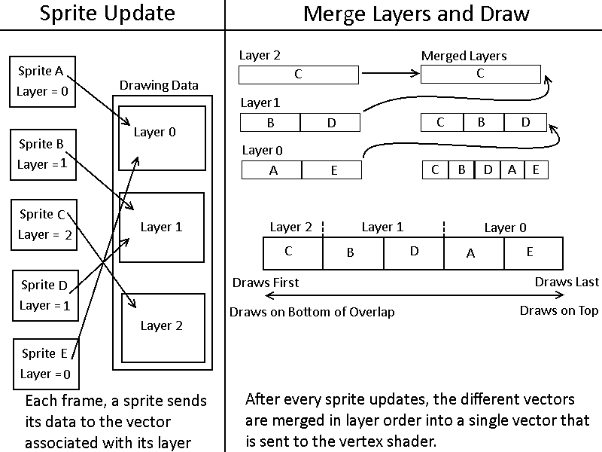

**Art Pipeline**

Instead of swapping textures in and out of the graphics card, all needed textures are packed into a single texture atlas as a pre-build step to running the game. However, this process is fairly automated. A third party tool called Sprite Sheet Packer does the majority of the work here, but the command line interface of Sprite Sheet Packer is wrapped in a batch file for convenience and time saving purposes.

To store certain data that Sprite Sheet Packer has no way of inferring, certain tags in filenames can be interpreted by the engine. For example, Character_4.png has the tag “_4”, which indicates this textures is a four frame animation. Another tag is the prefix NC~, which indicates that this sprite should not have collision if it is created as a tile.

An unfortunate side effect of using Sprite Sheet Packer, however, is that it expects to pack individual sprites, but not larger tilemaps. Designers/artists did not want to have to make tilemaps tile-by-tile, so we use a third party tool called ImageMagick to slice tile maps so that their individual tiles can be added to the atlas. Since ImageMagick is primarily a command line tool, a batch file in this case was less for convenience and more of a necessity.

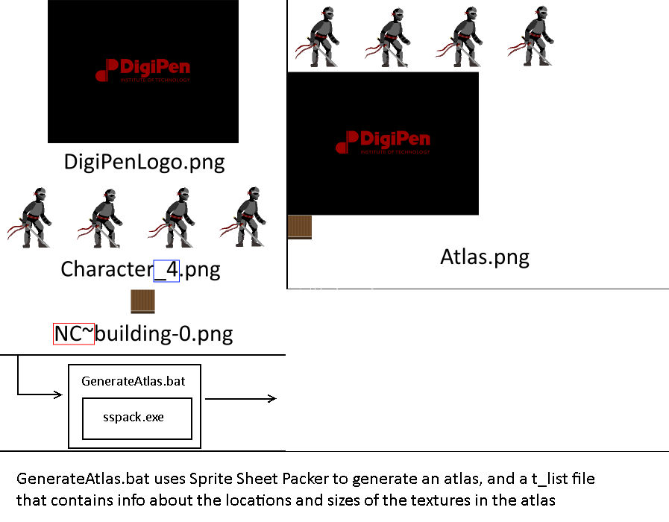

//tList_Atlas.png

//NOTE: Data is in form:

//X offset, Y offset, Width, Height

Character_4 = 0 0 768 192

DigiPenLogo = 0 193 512 384

NC~building-0 = 0 578 64 64

Generating the atlas and tList file is a pre-build step. At runtime, the engine will read the tList file. Textures are stored in a map in the graphics manager. The key is a just a string, the name of the texture, and the value is the texture itself, as an AtlasTexture object. AtlasTexture objects are basically containers for storing the relevant information that was read from the tList file.

**Animation**

With the knowledge that Sprite Sheet Packer will never “bump” an animation to the next line, and the width and number of frames are made available as part of the packing process. This makes animation is trivial, as all information needed to animate a sprite is accessible. The animation algorithm just determines what the texture coordinates of the current frame are. There’s two steps in animation: determining whether or not to change the current frame, and updating texture coordinates based on the current frame. Determining whether or not to change the current frame is just based on a timer, calculating texture coordinates is done by calculating the four bounds of the shape that defines the texture.

|  |
| --- |
| //Core animation functions  GLfloat AtlasTexture::getBottomY()  {  return (offsetY + frameHeight) / (float)atlasHeight;  }  GLfloat AtlasTexture::getTopY()  {  return offsetY / (float)atlasHeight;  }  GLfloat AtlasTexture::getLeftX()  {  return ((currentFrame * frameWidth) + offsetX) / ((float)atlasWidth);  }  GLfloat AtlasTexture::getRightX()  {  return ((currentFrame * frameWidth) + offsetX + frameWidth) / ((float)atlasWidth);  } |

**Sprite Text**

Although this feature was not fully fleshed out due to being low priority, our engine does support limited sprite text rendering. At this point, its best and most reasonable application is in displaying debug sprite text in the game world. This can be accomplished with a simple call to renderText, which will draw sprite text to the frame in which it was called.

|  |
| --- |
| static void renderText(  std::string message, Vector3 position, Vector3 scale); |

# PHYSICS OVERVIEW

The physics engine and libraries were originally written to accommodate C code, and has internally undergone several revisions.

Our rigid body supports the following properties and functionalities:

* Position
* Velocity
* Mass
* Acceleration
* Friction
* Restitution
* Ghost/Non-ghost
* Static/Dynamic
* Self-serialization
* Binding to the Zilch scripting language

Colliders in our engine don’t rely on our rigid body definitions. Box-to-box and box-to-circle collision detection are both supported. Colliders are self-serializing, and are bound to the Zilch scripting language.

math_utility.cpp - updated custom 2D&3D vector math library

math_utility.h - the struct for 2D&3D vector math and static functions that must in the header

PhysicsManager.cpp - contains the info of gravity, velocity and penetration value. The main part of the physics engine to loop through bodies/contacts and apply functions from rigid body and collider.

PhysicsManager.h - function headers and some properties.

Resolution.cpp - the most important and most complicated part to make the objects not penetrate each other while collision happened.

Resolution.h - function header.

Transform.cpp - Transform component for all the object/graphics that needs to rotate, scale, and get/set position.

Transform.h - function headers.

RayLineBoxCollision.cpp - simple ray-casting detection and returning all the informations when they collide.

BinaryMap.cpp - binary map collision for tile map, this is going to be a second semester goal.

Physics engine(version 2.0):

The C++ version of the 2D physics engine.

Body.cpp - the rigidBody that has all the informations of an physical object in the game as well as gettors/settors for changing the object's properties ( ghost/static/mass/rotation/velocity/gravity/impluse/inertia/kinematic/restitution)

Body.h - header class that inherit from the Game Component.

Collision.cpp - Collision detection method for box and box, circle and circle, box and circle.

Collision.h - function headers.

CollisionCheck.cpp - another collision check that removed the changes to the engine and for debugging only.

CollisionCheck.h - function headers.

math_utility.cpp - custom 2D&3D vector math library

math_utility.h - the struct for 2D&3D vector math and static functions that must in the header file.

PhysicsManager.cpp - the main part of the physics engine to loop through bodies/contacts and apply functions from rigid body and collider.

PhysicsManager.h - function headers and some properties.

PlayerState.cpp - player Controller that has the states for grounded/jumping and connect message/event system.

PlayerState.h - function headers and state class.

Collider.cpp - initialize, update, release the class for box and circle collider.

Collider.h - function headers for colliders, also setting the box's width and height inside of it.

Resolution.cpp - can apply impulse effect and correct the object's position when the collision happened.

Resolution.h - function header. The class is merging the collider and rigid body .

Transform.cpp - Transform component for all the object/graphics that needs to rotate, scale, and get/set position.

Transform.h - function headers.

Trigger.cpp - collision callback trigger.

Trigger.h - function header for collision callback.

Physics engine(version 1.0):

Vector2D.h - simple custom 2D vector math library for essential algorithm in the physics.

Shapes.h - typedef struct that contains several shapes we want to collide with.

range.h - include the functions that check if two shapes are overlapping and max/min distance range checking.

collision_detection_utility.h - helper functions for collision checking that include "clamp on range","rectangle corner","separating axis for oriented rectangle"

collision_detection.h - several collision detection method that includes "point and line/square/circle","box and box/circle/line"

movement_collision_detection.h - several collision detection method for moving objects that include"box and box/circle","circle and circle"

bouding_shapes.h - the hull for box and circle shapes.

Make sure these questions are answered:

* What techniques will be used to implement the physics design?

Custom 2D Physics.

* What type of integration will you use (Euler, Improved Euler, Verlet, Runge-Kutta)?

Euler for intergrate the rigidbody's position.

Use separate velocity for solving the infinite velocity while in contact.

* What type of space partitioning will you use?

A linked list that can push back and erase the rigid bodies.

* What type of collision detection will you use?

Mainly going to use box and box collision detection and ray-casting.

# BEHAVIORS OVERVIEW

Show/describe the structure of the AI/behaviors in your game.

Make sure these questions are answered:

* What types of algorithms will be used to implement the behavior design?
* Pattern movement? Pathfinding? State machines? Flocking? Influence maps? Genetic algorithms?

# EDITOR OVERVIEW

Show/describe the structure of how your editor works.

* How do you create/delete/copy objects?
* How do you move/rotate objects?
* How do you save/load levels?
* How do you update archetypes?

- Editor is in-engine, and made primarily using imGUI.

- Saves levels in two files. The first file contains the level name, as well as information about the levels’ tilemap. The second file contains the information of all game objects. It’s basically the output of our serializer.

- Editor supports a tilemap editor that displays all textures available in the game and allows the user to change the sprite of any tile to any of those available textures. Tiles are really only a sprite and sometimes collision, so we simplified this for tiles and linked collision info to sprite.

- Editor allows dynamic translation (click and drag), rotation (ctrl click and spin), and scale (shift click and drag). Just responds to mouse events and changes transformation properties like any other property.

- Editor allows adding/removing components. Although some components don’t actually truly activate until a level reload (which is as easy as the click of a button)

- Certain component properties can be tweaked at runtime. But they kind of have to be “bound.” I have do some very simple logic per property. The logic is mostly generalized, just not the identity of the property we’re reading from or writing to

# ADDITIONAL TOPICS

* Art pipeline
* Audio pipeline

Since we don’t have a sound designer in our team, and the guy who was originally doing the sound implementation left the team, physics programmer took over the sound implementation part.

Tools using: FMOD Studio 1.06.08

Implementation process:

- Commented the old FMOD code from the guy who left the team.

- Collect sound assets from the team producer and Digipen asset library.

- Add audio table in FMOD studio and generate .bank file for background music/ambience/combat music files.

- Collect FMOD Studio 1.06.08’s API to use in our engine. (Both API and the FMOD studio must be the same version. Otherwise the sound doesn’t work.)

- Create the sound manager based on FMOD studio’s API:

- add a container using Fmod::Studio::EventInstance to loop through all the sounds we need.

- Initialize the sound system by using FMOD::Studio::System::create(), and use FMOD_RESULT to and loadbankfile() to the load our bank file. Use FMOD_OK flag to check if the bank file load correctly.

- Call the update() in fmod studio.

- Use release(), unload(), unloadall() from FMOD Studio to shut down the sounds.

- Use getEvent(), createinstance(), isOneshot() from FMOD Studio to read in the music file name inside the .bank file and create an instance for it.

- Use isValid() to check if the sounds exist and use getplaybackstate() to check if the sound ends then call setpasued() and loop it again.

- loop through all sounds list and call the setpaused() to stop/pause/resume the sounds.

- Create the sound emitter that can call the functions without directly access the sound manager itself.

- added some flags so we can make sure when the sound play/stop by set the flag to true or false.

- To play background music, put code inside the core.cpp when the game start, to play movement or attack sounds, create a pointer in the header class, and call the function from sound emitter based on what action you take in the implementation.

- if we want to add new music without recompile the engine, drag new music file into FMOD studio and generate a new bank file, copy it and overwrite the bank file in the engine folder, change the music file’s name you called in the engine, and start debug, it should play the new sounds.

* Scripting languages